# [**‘Law & Order: SVU’ EPs Promise Rollins & Carisi’s ‘Love Will Prevail’ in Season 24’**](https://www.tvinsider.com/1058744/law-order-svu-season-24-rollins-carisi-kelli-giddish-leaving-details/)

[‘Produtores Executivos de Law & Order: SVU promete que ‘amor prevalecerá de Carisi & Rollins na Temporada 24’](https://www.tvinsider.com/1058744/law-order-svu-season-24-rollins-carisi-kelli-giddish-leaving-details/)

[***Ileane Rudolph***](https://www.tvinsider.com/author/ileane-rudolph/)

SEPTEMBER 15

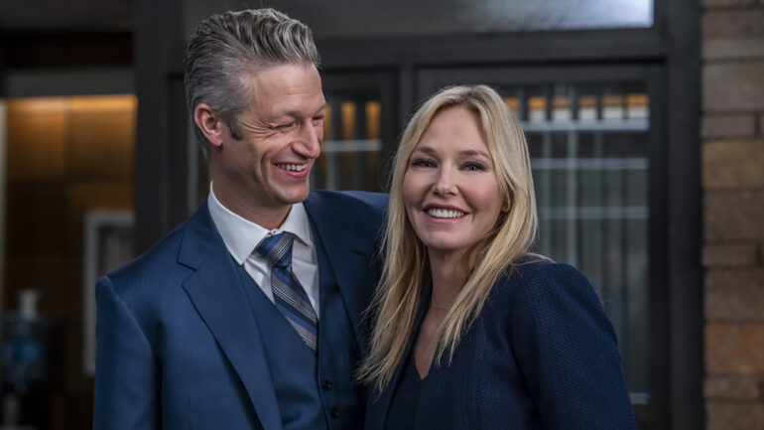

Zach Dilgard/NBC

[***Law & Order: SVU***](https://www.tvinsider.com/show/law-order-special-victims-unit/) Season 24’s second episode finds Benson in the Bronx for a sex-crimes case involving gang activity. As she tangles with the unit’s chief (Maurice Compte) over jurisdiction, she notices how skillfully his detective Grace Muncy ([**Molly Burnett**](https://www.tvinsider.com/people/molly-burnett/), [***Queen of the South***](https://www.tvinsider.com/show/queen-of-the-south/)) empathizes with a young female victim. Impressed, says exec producer David Graziano, “Benson brings her into the SVU.”

Segundo episódio da Temporada 24 de [***Law & Order: SVU***](https://www.tvinsider.com/show/law-order-special-victims-unit/)encontra Benson no Bronx para um crime de sexo envolvendo uma atividade de gangue. Enquanto ela se envolve com o chefe da unidade (Maurice Compte) sobre jurisdição, ela percebe quão habilmente sua detetive Grace Muncy ([**Molly Burnett**](https://www.tvinsider.com/people/molly-burnett/), [***Queen of the South***](https://www.tvinsider.com/show/queen-of-the-south/)) empatiza com uma jovem vítima feminina. Impressionada, disse o produtor executivo David Graziano, “Benson a traz para o SVU.”

[**Mariska Hargitay**](https://www.tvinsider.com/people/mariska-hargitay/) herself suggested an emotional arc exploring “how Benson looks inward to recognize her trauma” — including her torture by psychopath William Lewis ([**Pablo Schreiber**](https://www.tvinsider.com/people/pablo-schreiber/), Seasons 14–15) and perceived abandonment by Stabler ([**Christopher Meloni**](https://www.tvinsider.com/people/christopher-meloni/), now on [***Organized Crime***](https://www.tvinsider.com/show/law-order-organized-crime/)) — “and heal herself,” says fellow EP Julie Martin. The goal? “To become a better captain, friend and mother, and possibly consider a relationship.”

[**Mariska Hargitay**,](https://www.tvinsider.com/people/mariska-hargitay/) ela mesma, sugeriu um arco emocional explorando “quão Benson olha para dentro para reconhecer seu trauma” - incluindo sua tortura pelo psicopata William Lewis ([**Pablo Schreiber**](https://www.tvinsider.com/people/pablo-schreiber/), Temporadas 14–15) e abandono percebido por Stabler ([**Christopher Meloni**](https://www.tvinsider.com/people/christopher-meloni/), agora em [***Organized Crime***](https://www.tvinsider.com/show/law-order-organized-crime/)) - “e curar-se" disse a colega Produtora Executiva Julie Martin. O objetivo? “Tornar uma melhor capitã, amiga e mãe, e possibilidade de considerar um relacionamento.’

The original series and spinoffs 'SVU' and 'Organized Crime' are kicking off their new seasons with a major event.

A série original e spinoffs ‘SVU’ e ‘Organized Crime’ estão começando suas novas temporadas com um evento maior.

Meanwhile, Martin predicts “bumps” for Det. Amanda Rollins ([**Kelli Giddish**](https://www.tvinsider.com/people/kelli-giddish/)) and ADA Sonny Carisi ([**Peter Scanavino**](https://www.tvinsider.com/people/peter-scanavino/)) but says, “Their love will prevail.” Still, Giddish *is* [**departing this season**](https://www.tvinsider.com/1057672/law-order-svu-kelli-giddish-leaving-season-24-amanda-rollins/).

Enquanto isso, Martin prediz “solavancos” para Det. Amanda Rollins ([**Kelli Giddish**](https://www.tvinsider.com/people/kelli-giddish/)) e ADA Sonny Carisi ([**Peter Scanavino**](https://www.tvinsider.com/people/peter-scanavino/)), mas disse, “o amor deles prevalecerá.” Ainda, Giddish *está* [partindo essa temporada.](https://www.tvinsider.com/1057672/law-order-svu-kelli-giddish-leaving-season-24-amanda-rollins/)